**Facilities**

**Classrooms**

The college comprises of spacious and well ventilated rooms with modern infrastructure and comfortable sitting furniture

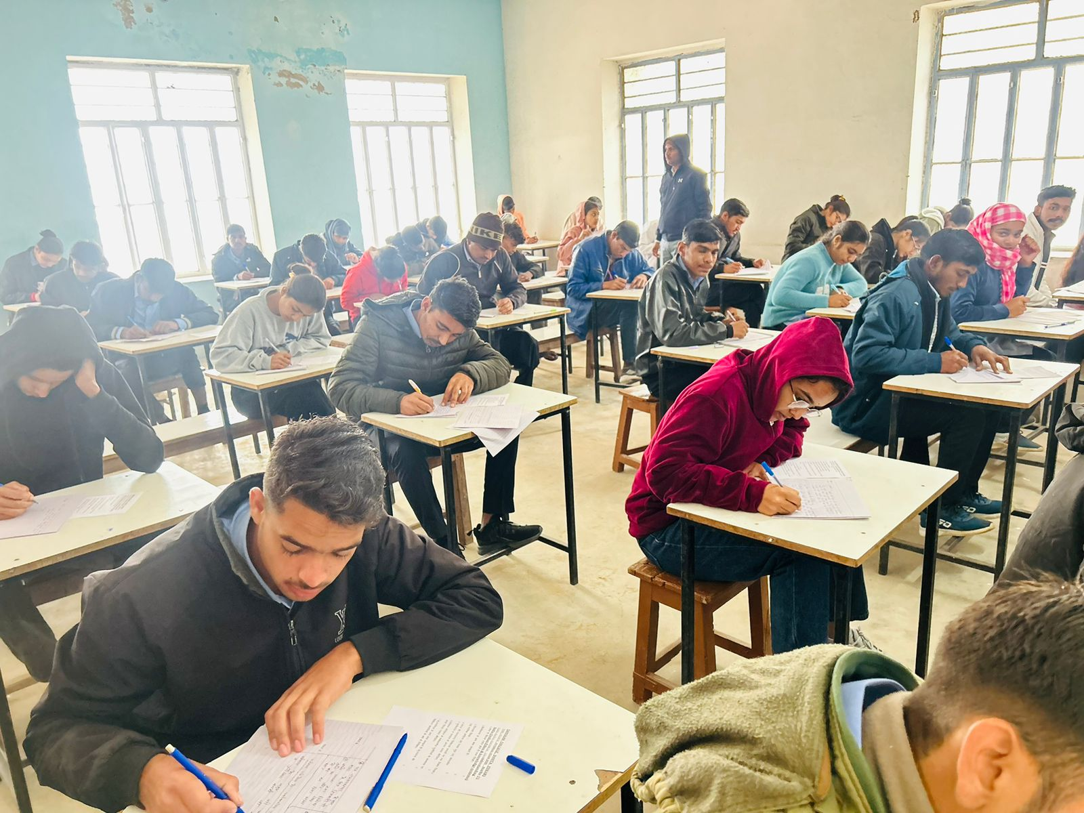

**Library With Reading Room**

The College has an excellent library and information centre. Central support services of the institution acts as primary source of information to students, faculty and research scholars. The library has sufficient number of books for reading and reference. Book bank facility is also available for the benefit of needy students. The library subscribes to all important News papers, Magazines, National and International journals on.

The College has an excellent library and information centre. Central support services of the institution acts as primary source of information to students, faculty and research scholars. The library has sufficient number of books for reading and reference. Book bank facility is also available for the benefit of needy students. The library subscribes to all important News papers, Magazines, National and International journals on.

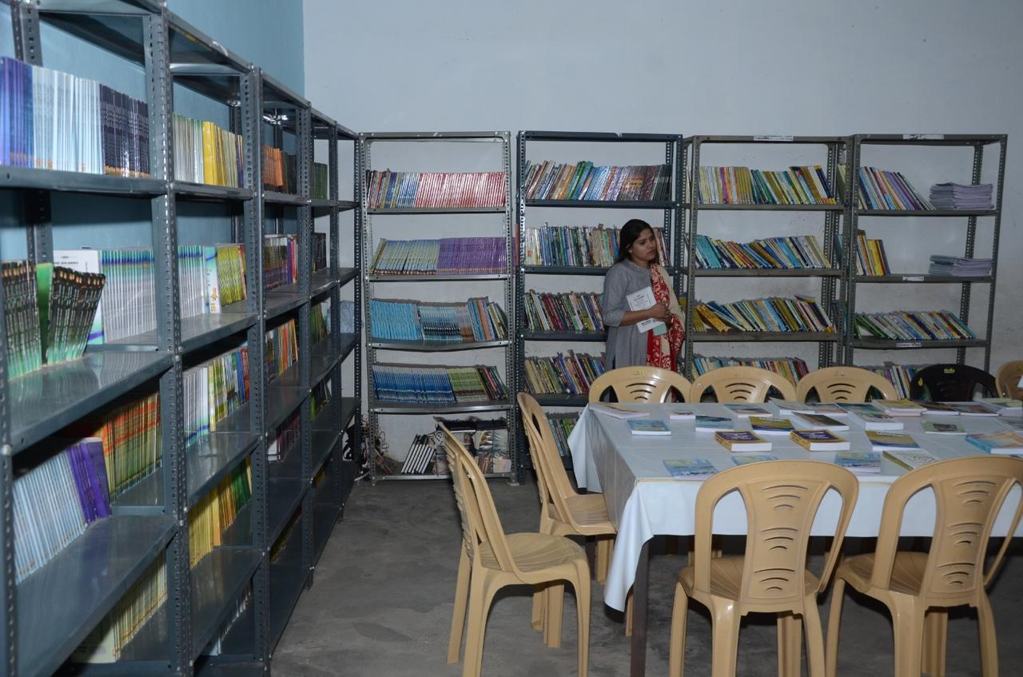

**Computer Laboratory**

Computer laboratory in the college is equipped with latest computers and high-speed internet is available to enable students to widen their knowledge with regard to the latest technological innovations in the field.

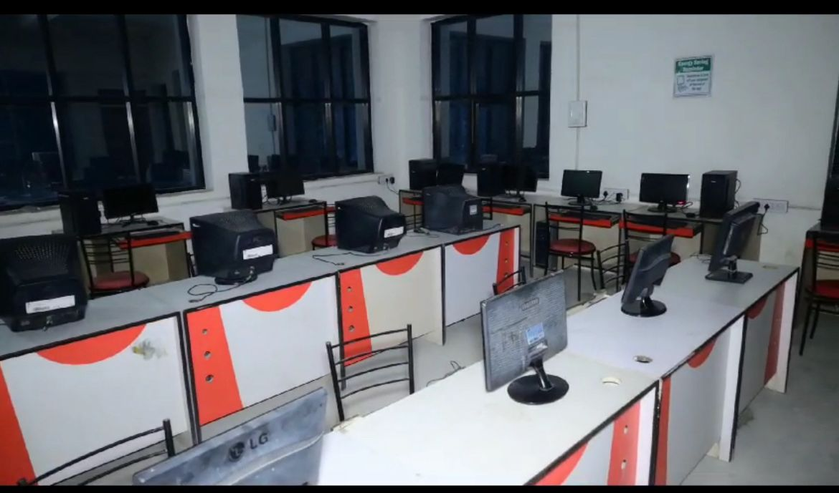

**Laboratories**

The college has spacious well designed, modern and equipped laboratories with preparation rooms responsive to current and future needs for performing practical tasks and research work. Machine room and instrumentation room are also available.

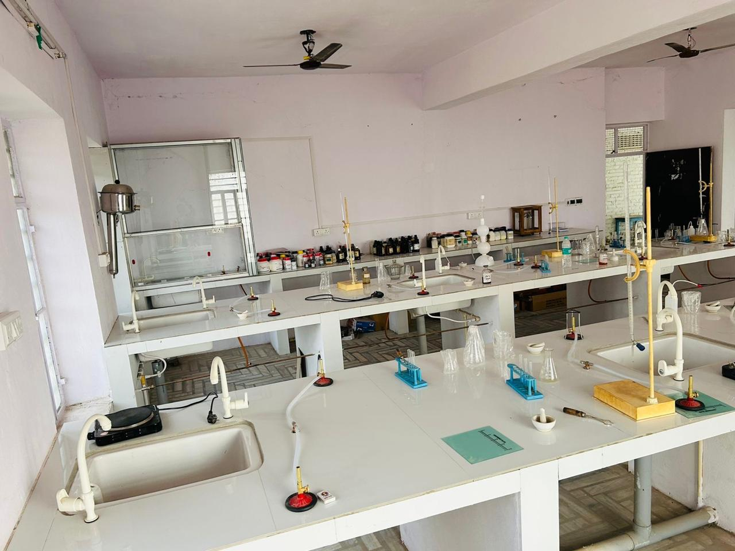

**Seminar Hall**

The college has well furnished seminar halls with state-of-the-art audio visual equipments. Regular guest lectures' by the dignitaries of national and international stature are arranged. Personality development and communication skill workshops are also organised regularly. The college believes in overall development of the students.

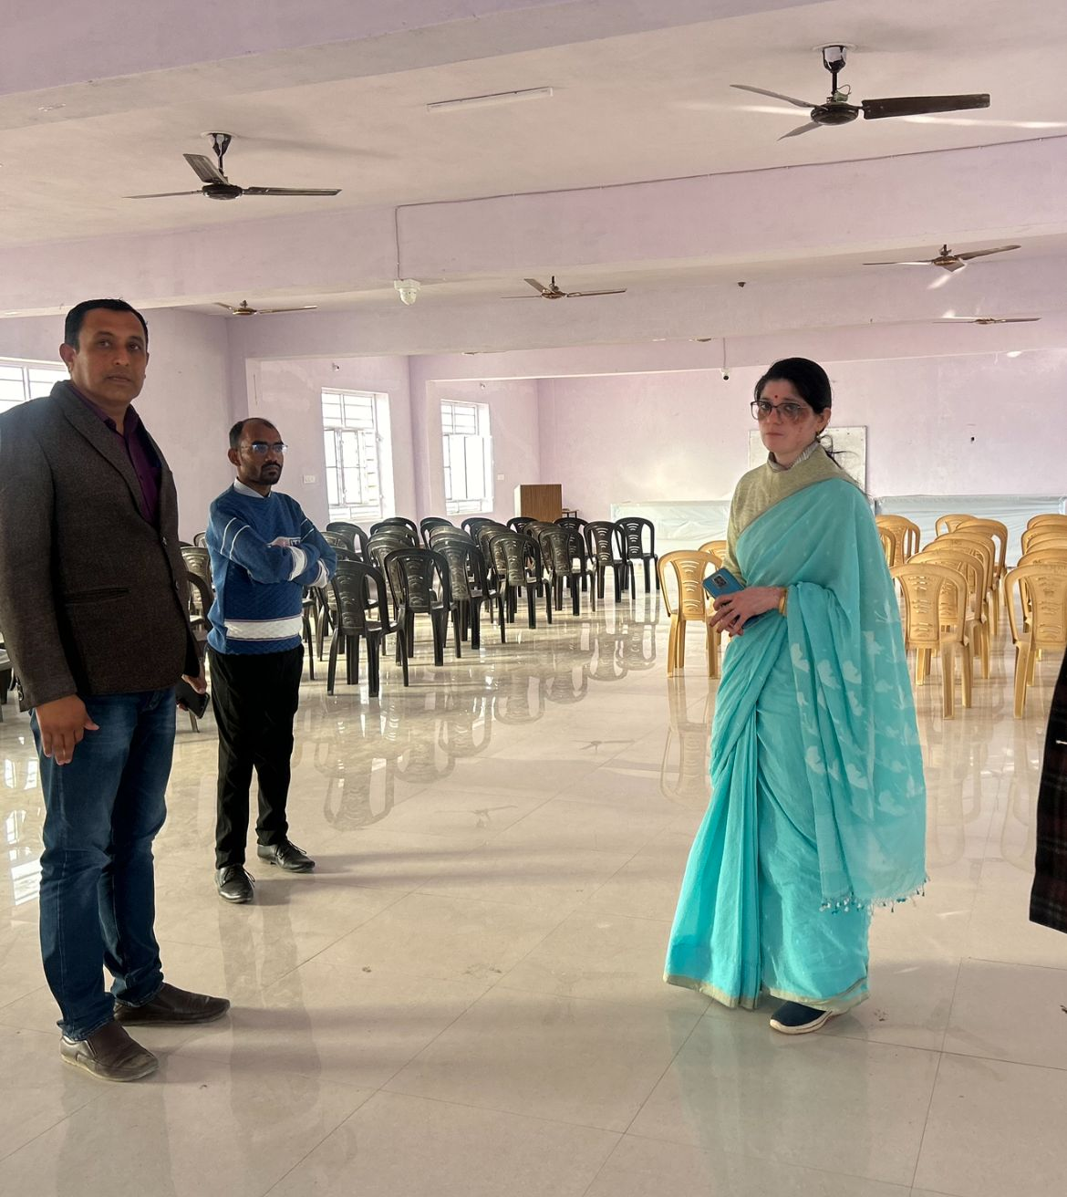

**Indoor Game Hall**

An indoor game hall is a facility designed for playing various indoor games and activities. These halls are often equipped with amenities and equipment to accommodate different types of games, providing a controlled and comfortable environment for participants. Some common features and activities found in indoor game halls include badminton, table tennis, basketball, volleyball, or indoor soccer and video games, pinball machines, and other electronic entertainment.

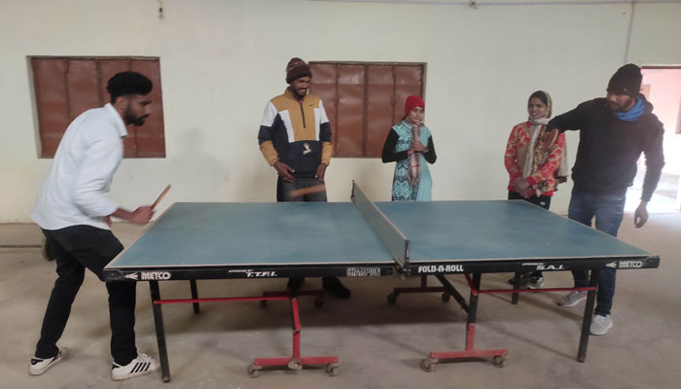

**Open Play Ground**

An open playground facility in a college provides a designated space for various outdoor activities, sports, and recreation. Here are some common features and aspects you might find in a college open playground facility.

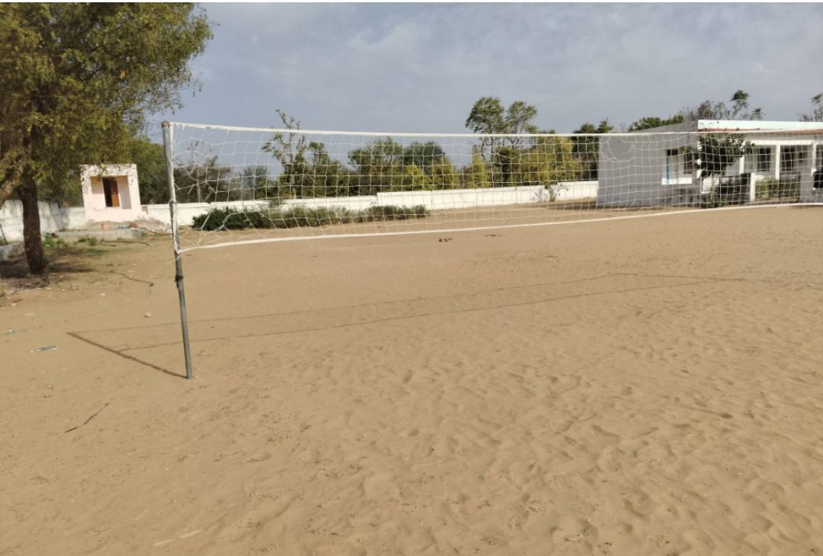

**CCTV Facilities**

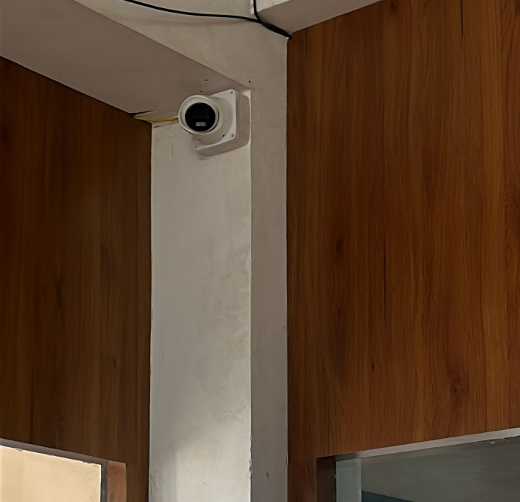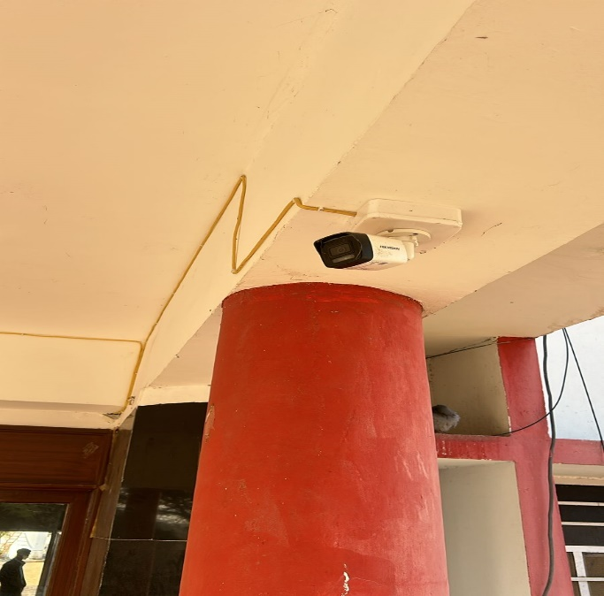CCTV (Closed-Circuit Television) facilities refer to the infrastructure and equipment associated with surveillance and monitoring using camera systems. These facilities are commonly employed in various settings for security, safety, and surveillance purposes. Here are some elements typically associated with CCTV facilities.

**Computer Room**

A computer room, also known as a server room or data center, is a dedicated space within a facility that houses computer systems, servers, networking equipment, and other related components. It serves as a centralized location for managing and maintaining the information technology infrastructure of an organization. Here are some key features and elements commonly found in a computer room.

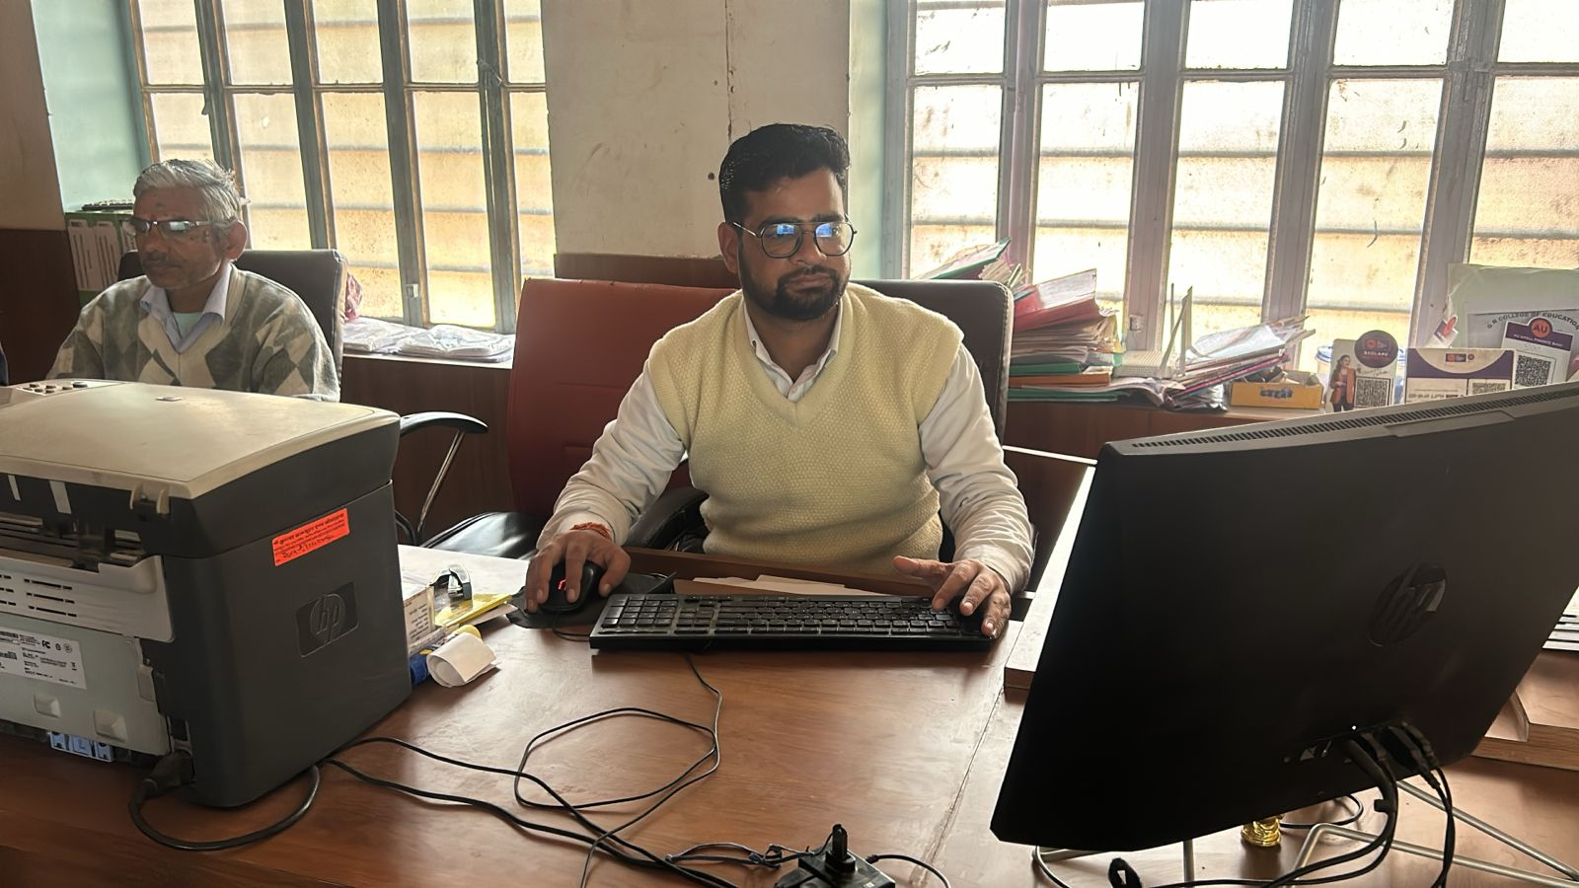

**Principal Room**

The principal's room in an educational institution, such as a school or college, is an important and typically private space designated for the principal's administrative and professional activities. Here are some common features and elements you might find in a principal's room.

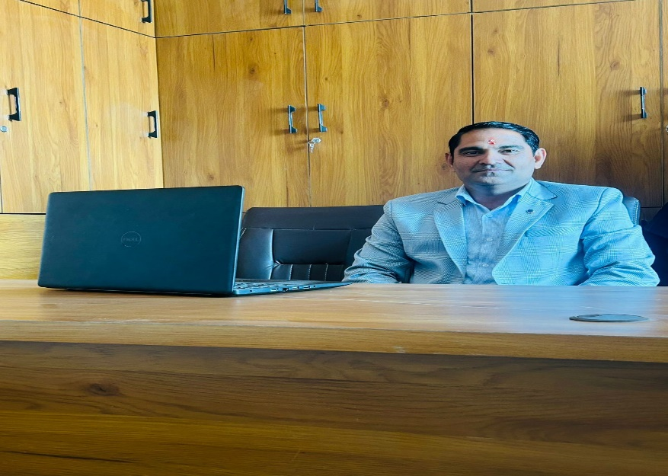

**Art and Craft Room**

An art and craft room is a dedicated space within an institution or facility designed for engaging in various artistic and creative activities. Here are common features and elements you might find in an art and craft room.

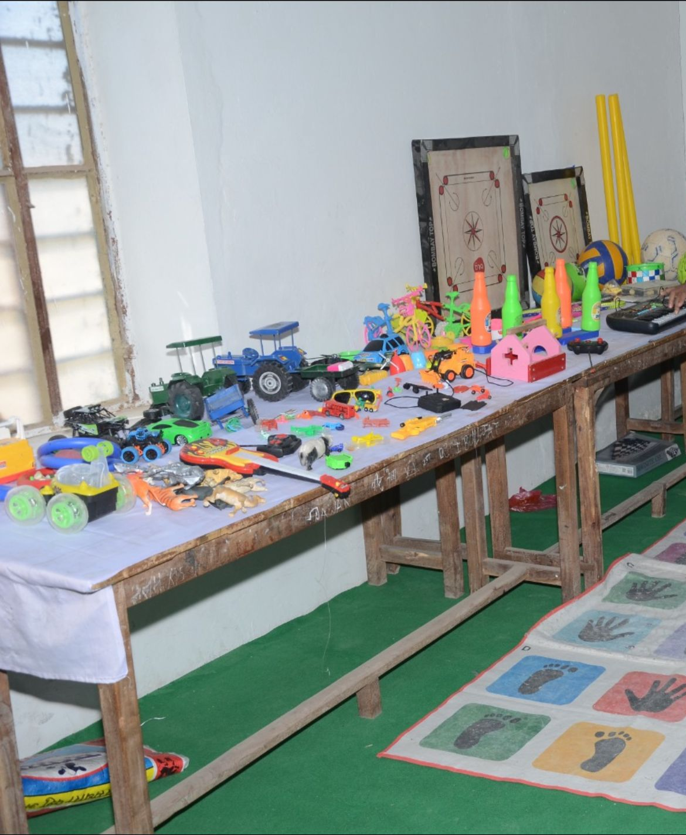

**Phycology Lab**

A guest house is a type of accommodation that provides lodging for visitors, usually in a more homely and intimate setting compared to a hotel. Guest houses can vary in size and amenities, but they generally offer a more personal experience. Here are common features you might find in a guest house.

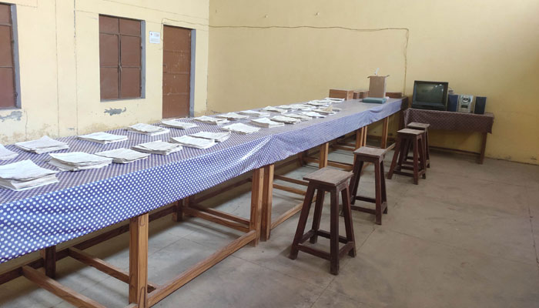

**Staff Room**

A staff room is a designated area within an organization or institution where staff members can gather, relax, and carry out various professional activities. Here are common features and elements you might find in a staff room.

